12/10/2014

This is my version of the UDV Axis Interface template modified for servo (V-command) control. Currently in LV2014, UDV axis properties still do not support servo parameters, so many of the servo parameters will have to be given manually to the FPGA. For ex: PID Gains, Limit Ranges, Position error limit, etc.

One thing to keep in mind is that in the LVPROJ, the axis is still configured as an open-loop stepper, except it can read encoder position from “Encoder 0”. If we had used closed-loop stepper, SM handles the position error limit and sometimes it gets hard to manage. That’s why we’re handling this manually.

Few things to note:

**To “reset” position** – Besides executing a reset position from RT, we need to reset the encoder counter on the FPGA as well. This can be found here:

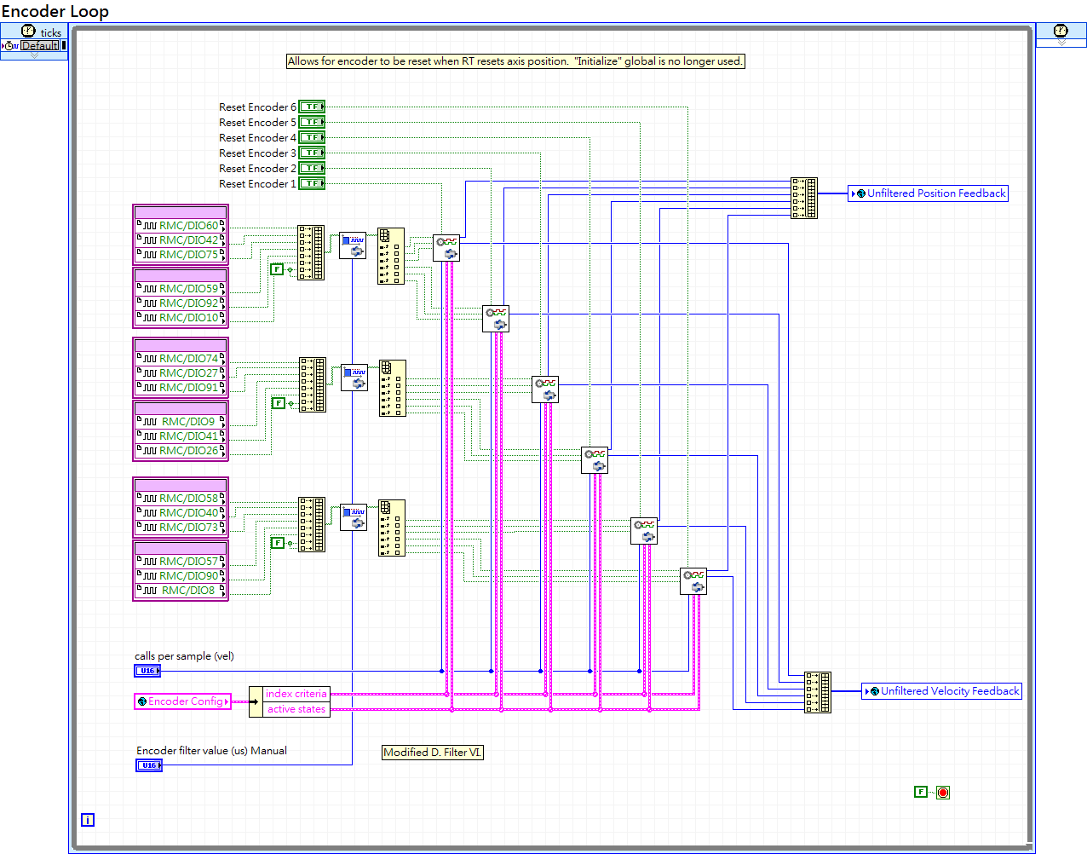

I could not find a hook from the RT method that would toggle this FPGA encoder reset automatically, so we’ll have to toggle this Boolean from RT manually. Proper operation requires us to:

1. Set AO value to 0 (using my AO override)
2. Wait for 20-50ms
3. Reset RT position, reset encoder position
4. Give AO control back to SM.

Other notes:

* Tuning PID parameters is still necessary.
* If following error occurs, proper procedure is re-sync RT trajectory and encoder.
* Still can’t reset the FPGA encoder to any arbitrary value.
* Velocity calculation is a little weird. Should hook this to the “Velocity Feedback” UDV in the future.
* FPGA is at 100%. Originally I could stuff 6 axes onto FPGA, but then I went back to 5 axes. sbRIO-9626 only has 4 channels of AO anyways.